Sales Report Pipeline — In-Depth Flow Diagram
Written 31 July 2026. It describes the system as it was on that day.
Document 1 showed the whole journey on a single page. This document takes the same journey and slows it down: nine stages, one at a time, each with the branch points where a report can quietly stop moving. The clerk is the same clerk — very fast, very literal, and stopping dead the moment something is not exactly where the instructions say.
Read each diagram first. The words underneath only add what a diagram cannot say: what you would see on screen, and what you would not.
- The nine stage names used here are the same ones used in the technical companion document, so the two line up stage for stage.
- Grey boxes mean stopped, quietly — the clerk puts the email down and moves on. Red boxes mean someone is told. The difference matters more than anything else in this document.

The nine stages, end to end
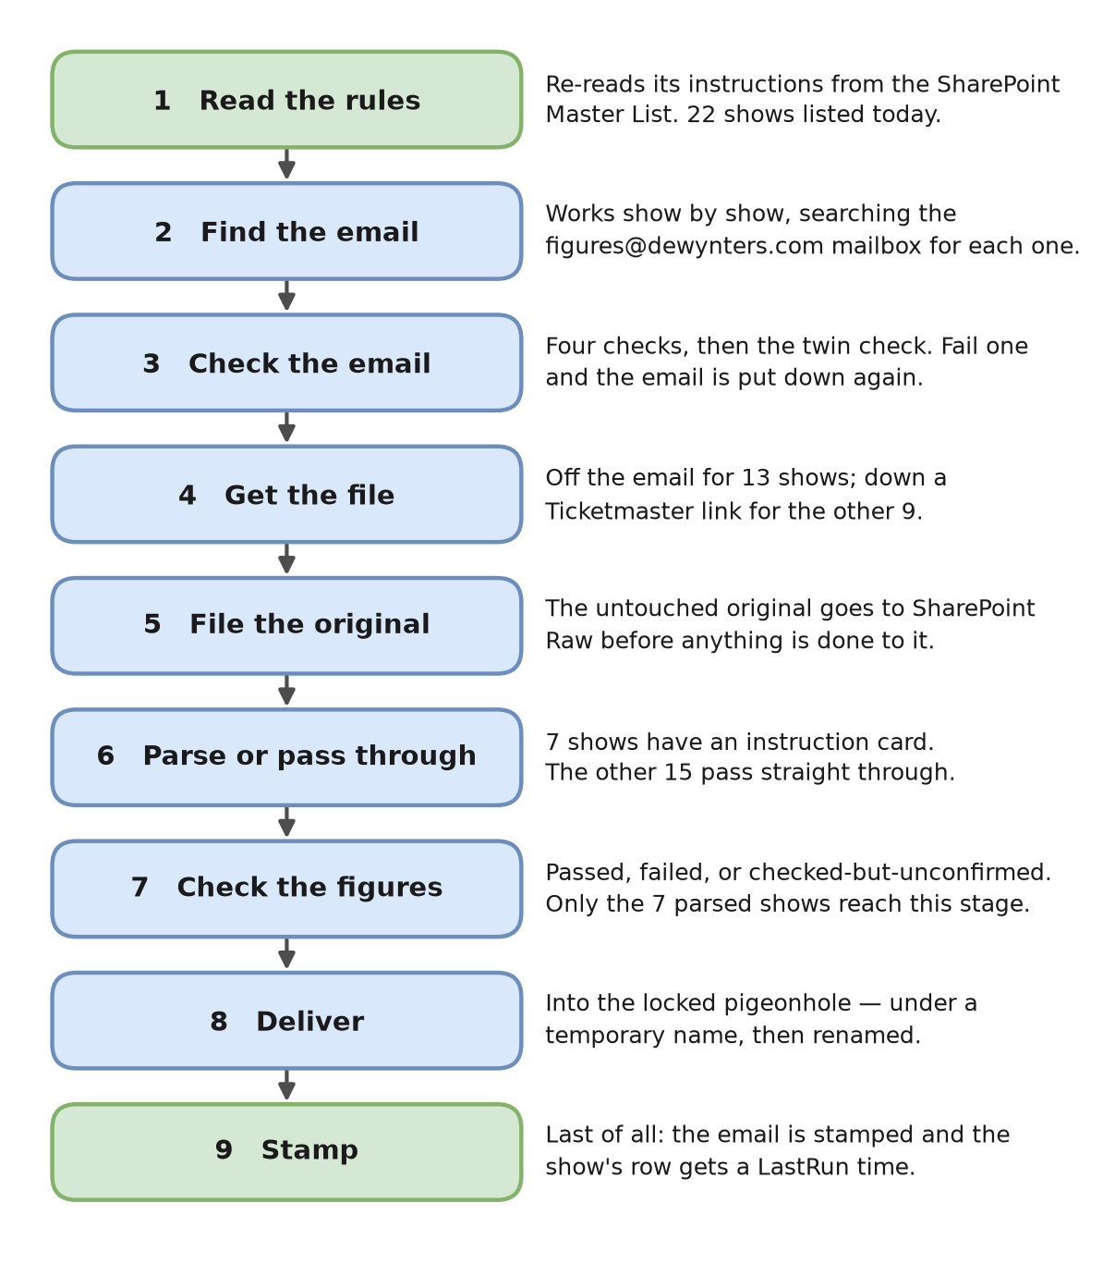
Figure 1 — The nine stages of a single round, and what each one does.

Stage 1 — Read the rules
Every round starts here, before a single email is touched. The clerk re-reads its instructions from the SharePoint Master List — 22 shows listed today — and nothing at all is remembered from the previous round. That is why a correction made in the list needs no restart and no rebuild: the next round simply reads the new instructions.
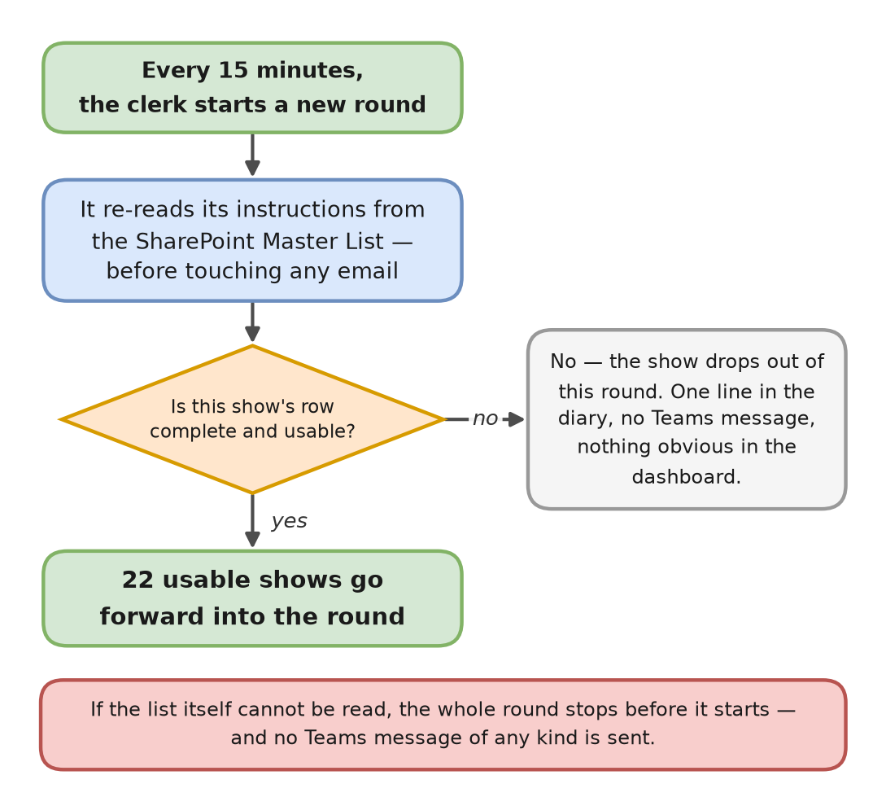
Figure 2 — Stage 1. The round begins with the instructions, not with the mailbox.
Not every row survives the reading. A row with no subject keyword, or no sender, or with only half of its instruction-card details filled in, is dropped from the round there and then. The other shows carry on unaffected.
When a row is rejected, nobody is told
There is no Teams message and nothing obvious in the dashboard — just a line in the diary. The show drops out of the round and its report stops arriving. This is the commonest reason a report 'just stops turning up' with no error anywhere, and it is why Document 1 says to leave every column except ShowID, VenueID and DocumentID alone.

If the list itself cannot be read, the round fails silently
A whole-round failure sends no Teams message of any kind — not a red card, not a summary. The only sign is a red Failed run in the Prefect dashboard. Always check the dashboard as well as Teams.

Stage 2 — Find the email
The clerk does not open the mailbox and look at what is in it. It works show by show. For each of the 22 shows in turn it takes that show's subject line, searches the figures@dewynters.com mailbox for it, deals with whatever comes back, and then moves on to the next show. Twenty-two separate searches, one after another — which is why a full round takes roughly three minutes rather than seconds.
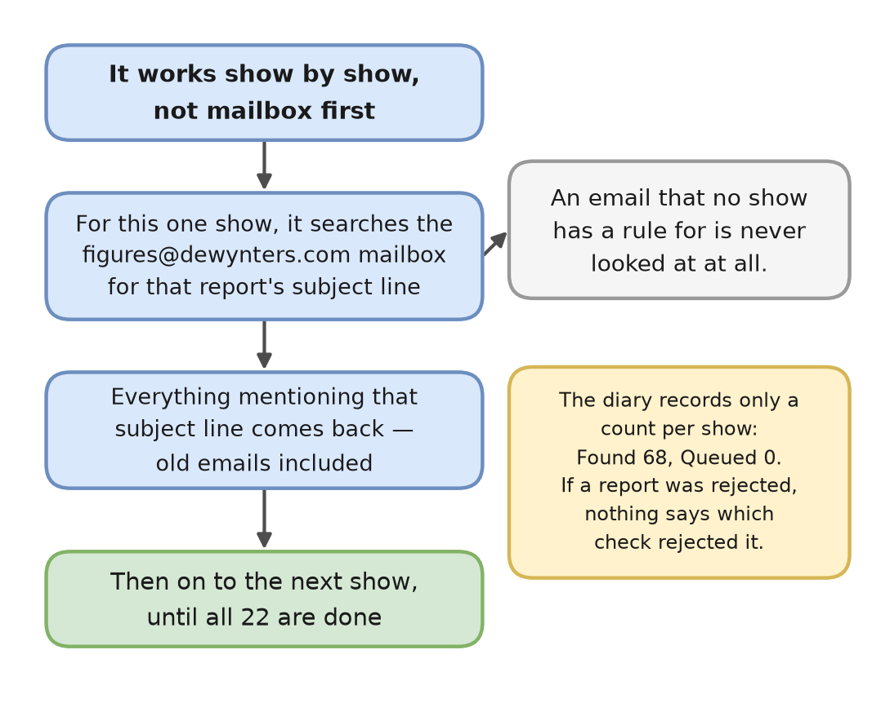
Figure 3 — Stage 2. Show first, mailbox second.
Two consequences follow, and both are worth knowing:
- An email nobody has a rule for is never seen at all. There is no step that looks at an unfamiliar email and asks what it is. Such an email is not rejected — it is simply never looked at. If a new show's report starts arriving before its row exists in the list, the pipeline is not ignoring it; it does not know it is there.
- The diary records only a count. Each show gets one line, e.g. Found 68, Queued 0. Found is how many emails mentioned that subject line at all; Queued is how many got through the checks in Stage 3. Zero queued on every show is the healthy resting state, exactly as Document 1 describes.
The blind spot in this stage
If a report was found but rejected, that show's line still reads Queued 0. It does not say which check rejected it, and it does not say that anything was rejected. A quiet week and a broken report look identical from the outside. When a show stops arriving, this is the stage that will not tell you why.

Stage 3 — Check the email
Everything that came back from the search now has to get past four checks, and then a fifth of a different kind. Fail any one of them and the clerk puts that email down and moves on. Nothing is deleted and nothing is broken — the email simply does not advance.
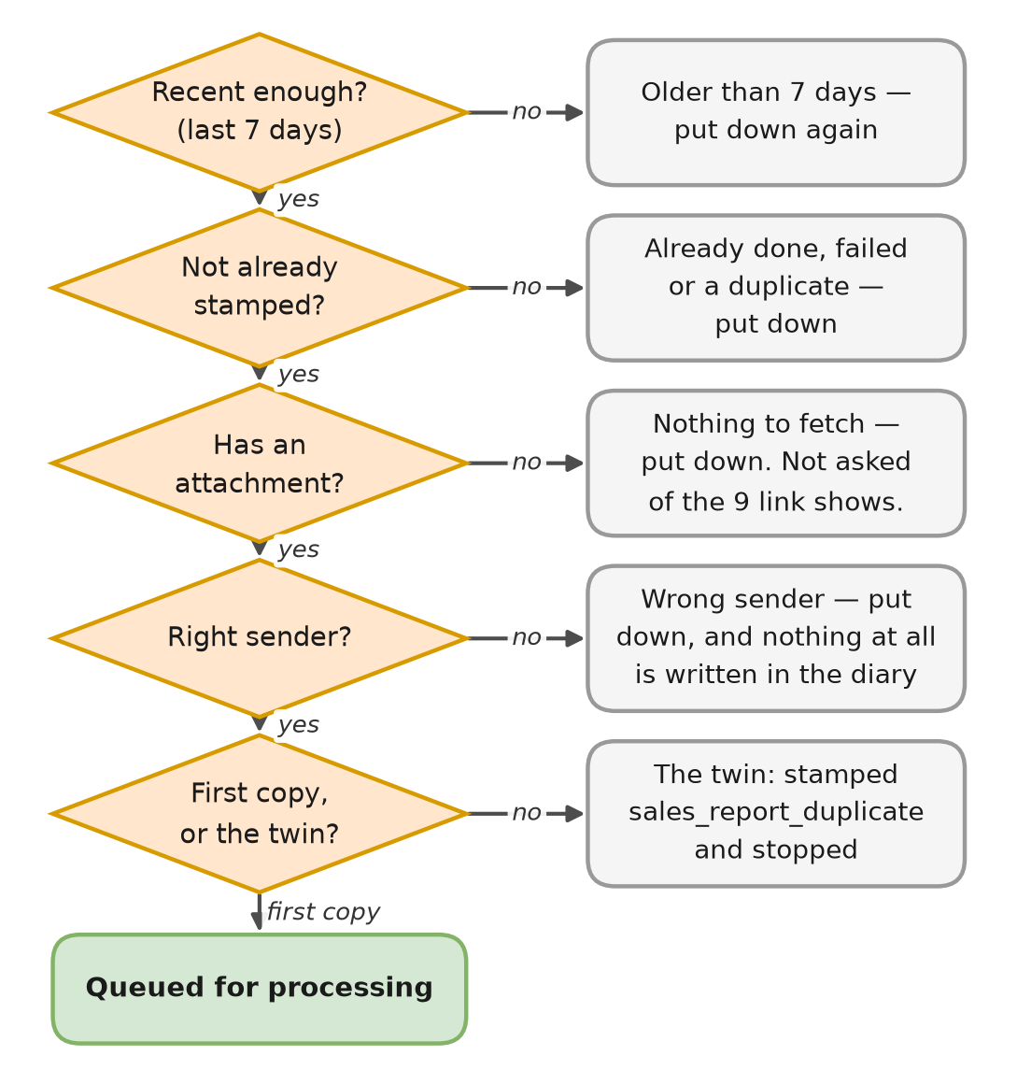
Figure 4 — Stage 3. Four checks, then the twin check.
- Recent enough. Received in the last seven days. The seven-day window is also the recovery mechanism: after an outage, the next round re-checks a week of email, so nothing is missed.
- Not already stamped. An email already stamped as done, failed or duplicate is left alone. This stamp is the only thing stopping the pipeline processing the same report every 15 minutes for a week.
- Has an attachment. Asked of the 13 attachment shows only. The 9 shows that receive a download link are not expected to have one.
- From the right sender. This is the one check that leaves no trace at all in the diary when it rejects something. If a vendor changes the address they send from, the report disappears with no message and no log line — only Queued 0.

The fifth check — the twin
Every report email arrives twice, on purpose. The first copy is processed all the way through; the second is stamped sales_report_duplicate and stopped. That is the commonest thing in the diary and it is entirely normal.
But two copies of an email are not always a duplicate. Two different shows can legitimately claim the same one. Moulin Rouge / Shanghai and Moulin Rouge / Guangzhao share the same sender and the same subject line, so both rows match the same email — and that is deliberate. The only thing telling them apart is a keyword in the attachment's filename: MRSH picks out Shanghai's file, MRGZ picks out Guangzhao's. Each show takes its own attachment from the one email.
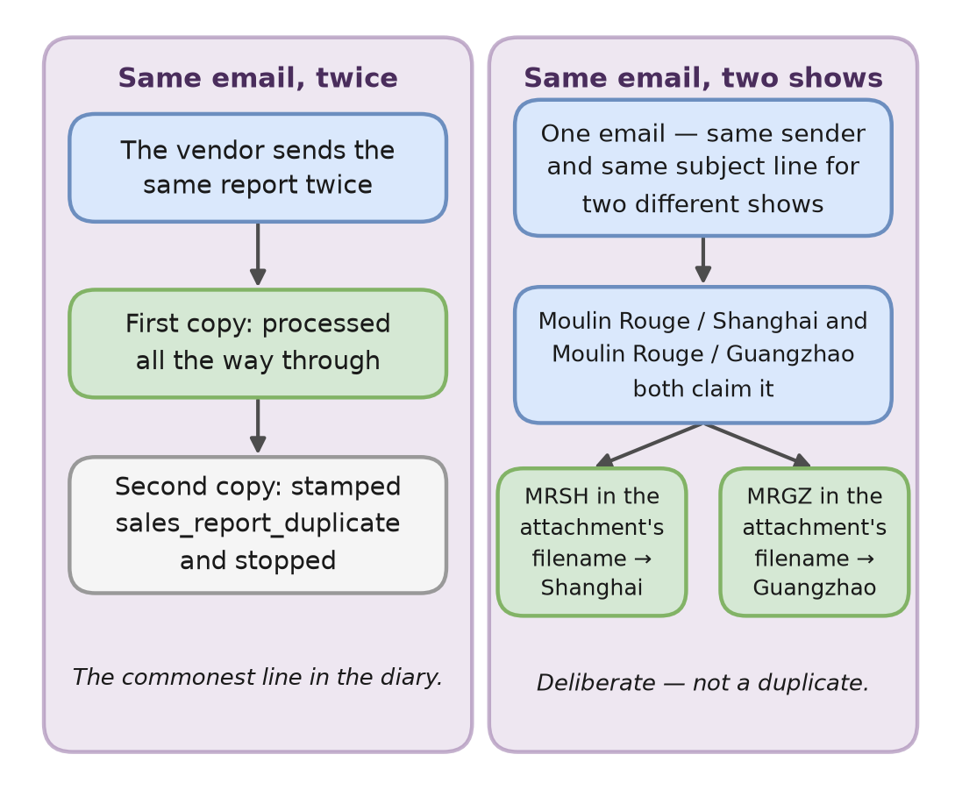
Figure 5 — Stage 3, the twin check. Two copies of one email (left) and one email claimed by two shows (right).

Stage 4 — Get the file
The clerk now needs the actual spreadsheet. Thirteen of the 22 shows attach it to the email, which is the simple case. The other nine send a download link instead — mostly Dublin Bord Gáis Energy Theatre shows, six of which share that one venue, so a single change to the vendor's email template can break several shows at once.
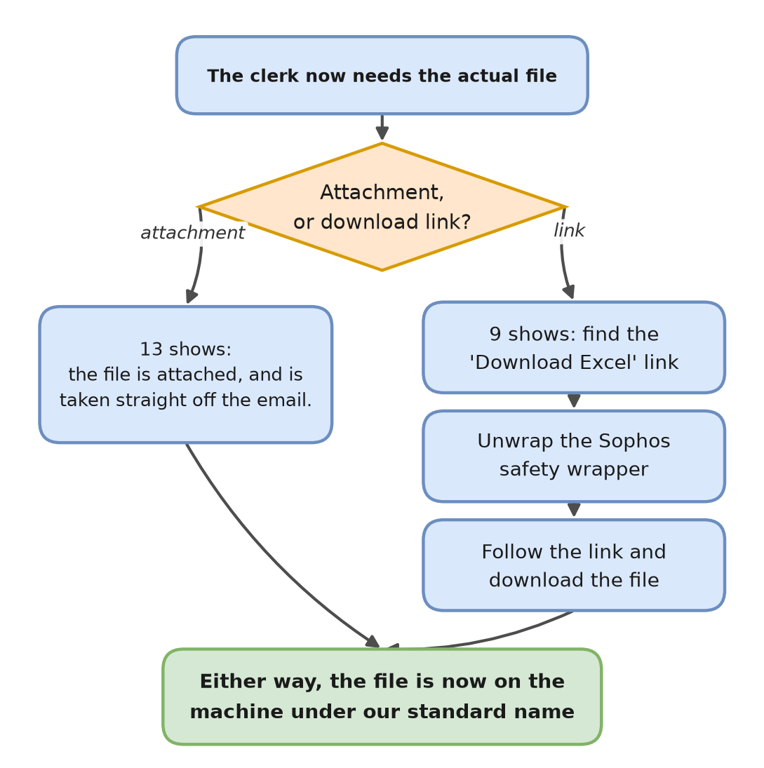
Figure 6 — Stage 4. Two routes to the same file.
The link route has three steps, and each can fail in its own way:
- Find the link. The clerk looks for the 'Download Excel' link in the body of the email. If the vendor renames or restyles it, the card reads Could not find a valid Sophos/Ticketmaster download link in email body.
- Unwrap the safety wrapper. Every link in incoming email is rewritten by Sophos, our email security service, into a scrambled address of its own. The clerk has to unscramble it to find the vendor's real address underneath. If it cannot, the card reads Failed to decode the Sophos wrapper link.
- Follow it and download. These are one-time links. If one has already been used or has expired, the card reads 403 Client Error: Forbidden.
Nothing here checks that what arrived is a spreadsheet
A download that quietly returns a web page — an error page, or a login prompt — is saved as if it were the report. For a show with an instruction card that surfaces later as a parsing failure. Document 1's check is still the fastest one: open the file in that show's SharePoint Raw folder and see whether it opens as a spreadsheet or as a web page.

Stage 5 — File the original
Before anything at all is done to the file, the untouched original is filed in SharePoint under the show's and venue's folders, in Raw. Only then does the clerk try to read it. The order is the whole point of this stage.
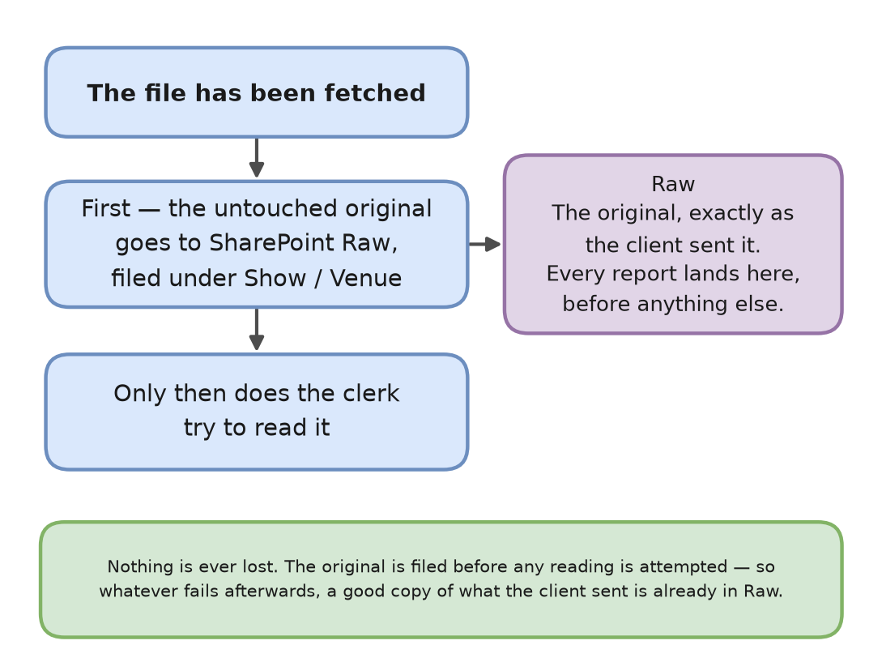
Figure 7 — Stage 5. The original is filed first, read second.
This is the reassurance to hold on to for the rest of the document: nothing is ever lost, because the original is filed before any reading is attempted. Whatever goes wrong afterwards — an instruction card that cannot read the file, a delivery that will not connect, a stamp that fails — there is always a copy of exactly what the client sent, in Raw, under that show and venue. Every one of the 22 shows gets a Raw copy, parsed or not.

Stage 6 — Parse or pass through
Seven of the 22 shows have an instruction card: a set of directions for reading that one client's report — which column holds the ticket sales, which row holds the totals. The other 15 have none, and are passed straight through, exactly as the client sent them.
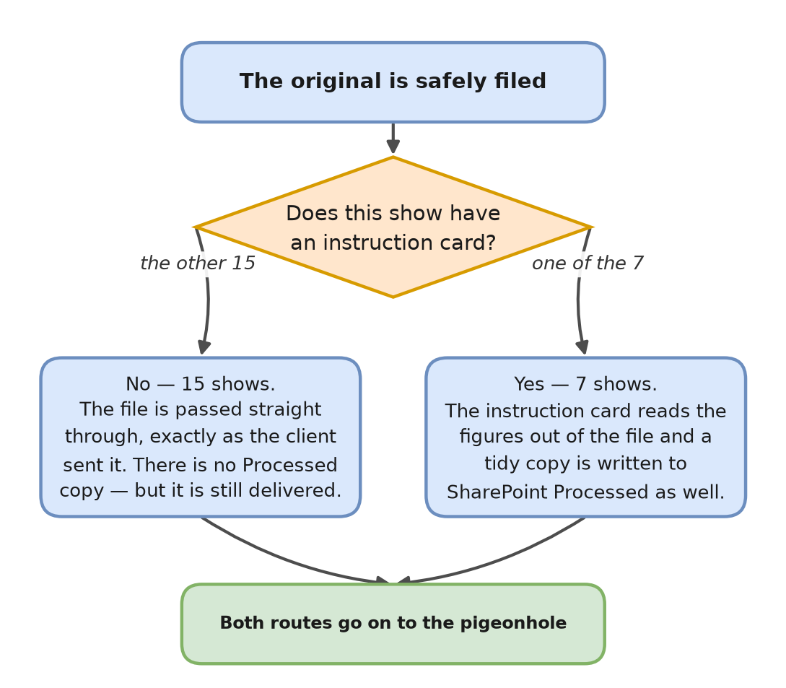
Figure 8 — Stage 6. Seven shows are read; 15 are carried.
A missing Processed copy is not a fault
Only the seven parsed shows produce a Processed copy in SharePoint, because only they produce a tidied file. If you go looking for a Processed copy for one of the other 15 there is nothing there, and there never was. Those shows are still delivered — the original file itself is what goes to the sales database.

Stage 7 — Check the figures
This stage exists only for the seven shows with an instruction card. As well as reading the figures out, the card checks that the totals add up. There are three possible outcomes, and the middle one is the one the team is least likely to know about.
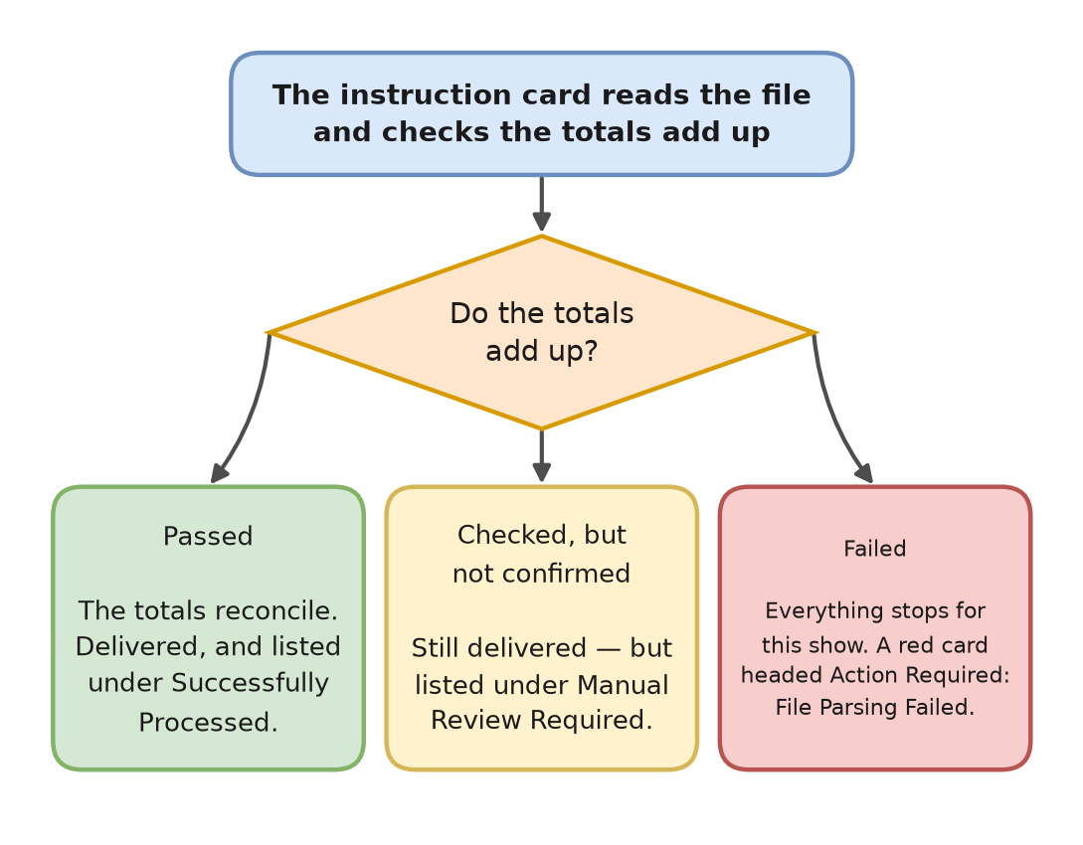
Figure 9 — Stage 7. Three outcomes, only one of which is red.
- Passed. The totals reconcile. The report goes on to delivery and appears under Successfully Processed in the end-of-round summary.
- Failed. Everything stops for that show. A red card headed Action Required: File Parsing Failed is posted, naming the show and venue, with text starting Validation Failed: and usually naming the exact column or row that went missing. Nothing is delivered for that show. Every other show in the round lands normally.
- Checked, but not confirmed. The card read the file but could not confirm the totals either way. This is neither a pass nor a failure: the file is still delivered, and it is listed under Manual Review Required in the end-of-round summary in etl-success.
Nothing red is posted for a checked-but-unconfirmed report
It is not in the errors channel, it is not a failed run, and the figures have already gone to the sales database. The only place it ever appears is the Manual Review Required section of the summary card. If nobody reads that section, an unconfirmed report can go unnoticed indefinitely.

Stage 8 — Deliver
Delivery is the drop into the locked pigeonhole — the secure way of putting a file onto the machine that holds the sales database. It happens in two moves rather than one, and that is the detail worth understanding, because it is genuinely clever.
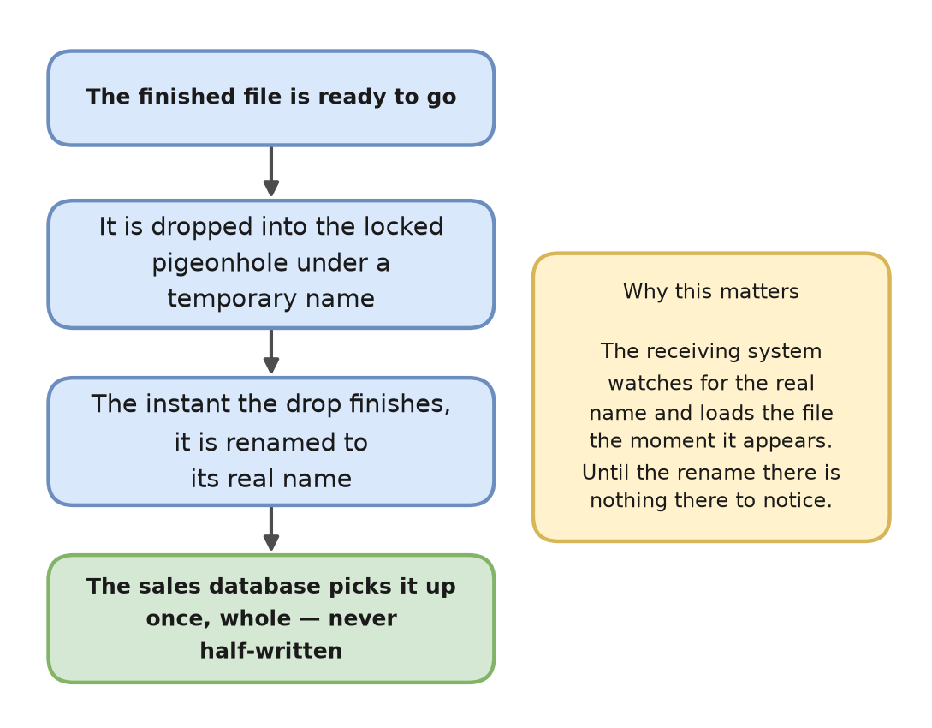
Figure 10 — Stage 8. Dropped under a temporary name, then renamed.
The receiving system watches for the file's real name and starts loading it the moment it appears. So the clerk drops the file under a temporary name first, and renames it only when the drop has finished. Until the rename there is nothing there for the sales database to notice; the rename itself is instant. The result is that the file appears complete or not at all — the database can never load half a report, and never loads the same one twice.
The 'failed' folder is not the whole story
When something goes wrong before the file has been read, the file is set aside in the failed folder and can be compared with the previous day's version. That is Document 1's advice, and it holds — but only for early failures. If a delivery or a stamp fails, the file has already moved on, so nothing at all is put in failed. Someone looking there after a delivery failure will find an empty folder, while the Raw copy, the Processed copy and the tidied file all exist. The email is stamped failed even though those copies are sitting in SharePoint.

Two shows are in test mode right now
There is a branch inside Stage 8 that Document 1 does not mention, and it is the single most operationally significant thing in this document. Each row in the list can be marked as a test. When it is, the file is renamed with TEST. in front of it and dropped into a separate test pigeonhole — so the figures never reach the live sales database.
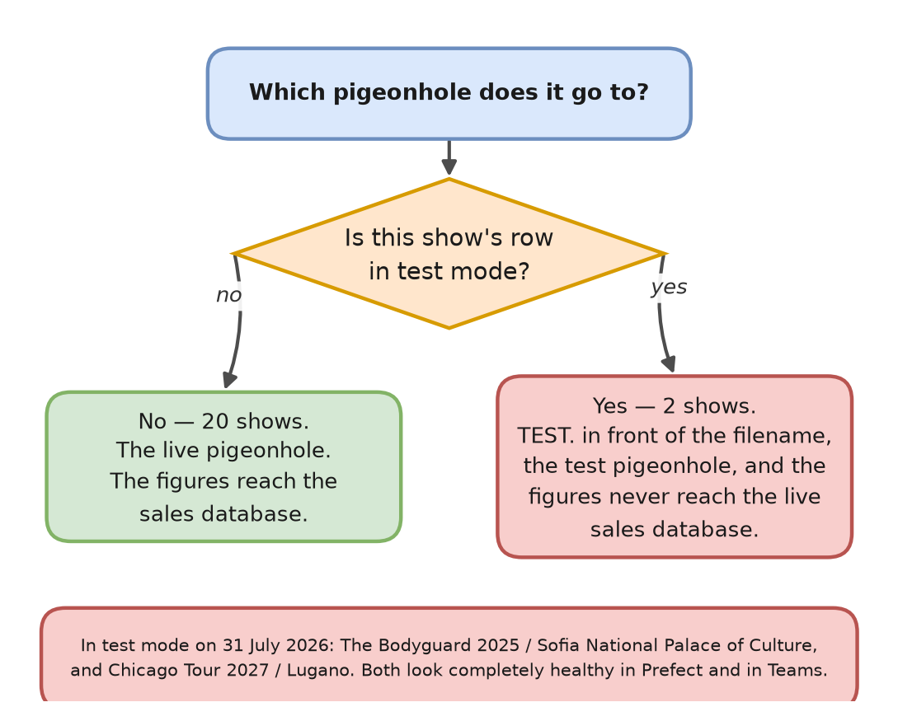
Figure 11 — The test-mode branch inside Stage 8.
Show | Venue | What happens
The Bodyguard 2025 | Sofia National Palace of Culture | Delivered to the test pigeonhole, filename prefixed TEST.
Chicago Tour 2027 | Lugano | Delivered to the test pigeonhole, filename prefixed TEST.

Everything else about these two shows looks correct. Their emails are found, their files are fetched, the originals are filed in Raw, their instruction cards read them, delivery succeeds, the email is stamped and the row gets its LastRun time. They appear in the etl-success summary alongside everything else. In the Prefect dashboard the runs are green. There is no red card, no warning and nothing in the diary that reads as a problem.
If either of these is supposed to be live, nothing will tell you
The only two ways to spot it are to look at the Test column on that show's row in the Master List, or to notice TEST. in front of the filename in that show's Raw and Processed folders. Treat the Test column exactly like SubjectKeyword and SenderDomain: leave it alone unless you mean to change it, because ticking it stops the figures reaching the sales database while everything continues to look healthy.

Stage 9 — Stamp
The last thing the clerk does for each report is write down that it is finished. The email is stamped sales_report_extracted, and that show's row in the Master List gets a LastRun time. Both happen after delivery, not before.
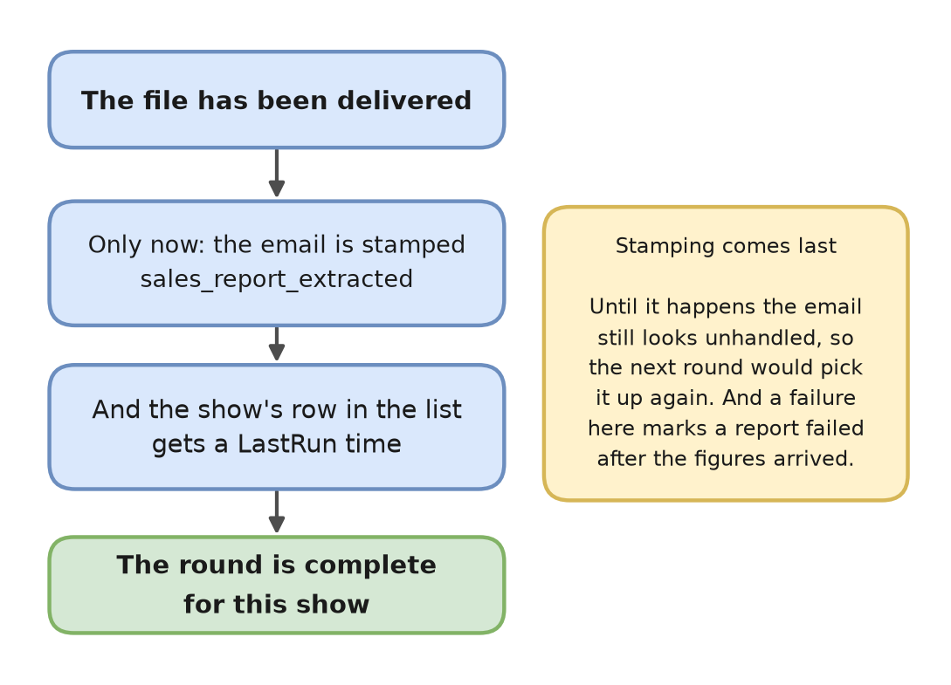
Figure 12 — Stage 9. Stamping happens last, after the figures have gone.
The ordering has two consequences. Until the stamp is on it, the email still looks unhandled, so a round that stops between delivery and stamping will pick the same email up again next time. And if the stamp itself fails, the report is marked as failed even though the figures arrived safely — a red card for a delivery that actually worked.
The LastRun time is also the cross-check Document 1 recommends when you are hunting for the right row among 22: the most recently stamped row is the live one.

Three shows have not been stamped since July
On the list as it stood on 31 July 2026, 19 of the 22 rows carried a LastRun time. Three did not: Jesus Christ Superstar / Taiwan, Jesus Christ Superstar / Manila, and Waitress Tour 2026 / Dublin Bord Gáis. That does not mean they have never worked. The LastRun stamp was only introduced on 20 July 2026, so a blank one means “nothing since then” rather than “nothing ever”. All three have delivered earlier in the year: Taiwan last produced a file for the 28 June sales day, Manila for 31 May, and Waitress for 24 May — against 30 July for a show that is running normally. The fair reading is that these three stopped delivering some weeks ago and have not restarted: the clerk still searches for them every round and still finds emails, but queues none of them. That is a statement of fact rather than a diagnosis; each of the three would need looking at on its own.

Where the alerts actually go
Two Teams channels are involved, and they are not interchangeable. Every failure goes to the errors channel. Only the end-of-round summary goes to the success channel. Nothing else is ever sent.
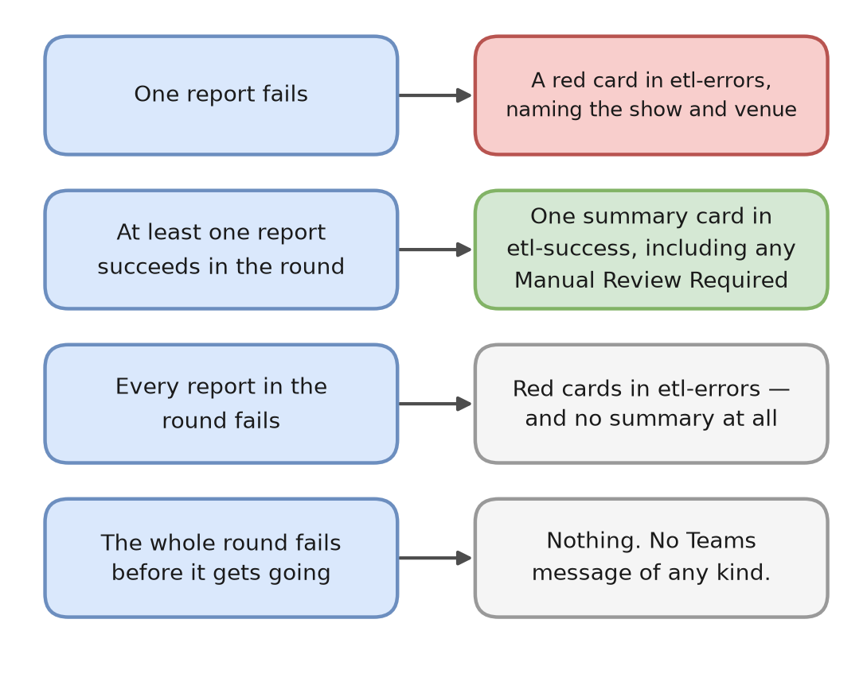
Figure 13 — What gets said, and to which channel.
- Every failed report posts a red card to etl-errors, naming the show, venue and rule, with a View Prefect Logs button that opens that run. Where the summary says 'See Dev channel for details', it means etl-errors.
- Only the end-of-round summary goes to etl-success — one card per round, listing what succeeded and what needs manual review.
- The summary is only sent if at least one report succeeded. A round in which everything failed produces red cards and no summary at all. So an absent summary can mean two very different things: nothing arrived, or everything broke.
- A whole-run failure sends nothing whatsoever. No red card, no summary, no warning. Nor does a dead machine, because the thing that sends the Teams messages lives on it.
Which is why the order in Document 1 holds, and why it is that order: dashboard first, Teams second, diary third. Teams will tell you about an individual report that failed. Only the dashboard will tell you whether the round happened at all.

